[Link to experiments sheet](https://docs.google.com/spreadsheets/d/1DH-nGghvkw4_CInabNSpqPNKxEo_Cof2iFQw0dM-YTo/edit?usp=sharing) , [Link to Colab](https://colab.research.google.com/drive/1B7CsEPDvHHrY5wOP48hybB-kpOyHZ-Wg)

**Implement the Alexnet models in Keras.**

Summarize Accuracy measures for Train, Test and Validation for the best model: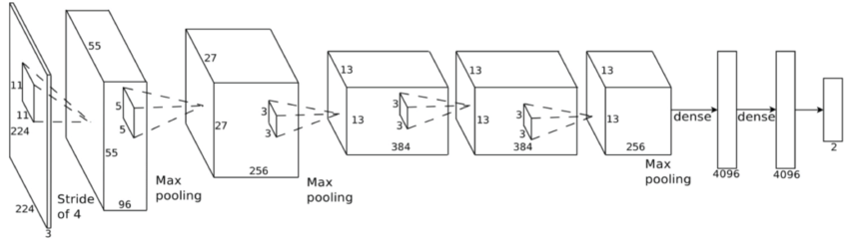

Key Takeaways of Alexnet:

* It contains 5 convolutional layers and 3 fully connected layers.
* Unlike previous models Alexnet used ‘Relu’ activation instead of ‘Tanh’ to add non-linearity.
* Use dropout instead of regularisation to deal with overfitting. However the training time is doubled with the dropout rate of 0.5.

The image size in the above architecture chart should be 224 * 224, but we were asked to work on 32*32 image size. So, we used the 32*32 image data and applied it to Alexnet. Also, made some changes to the model and then trained the model.

Some of the changes to the original alexnet are:

* Changed the input to (32,32)
* Changed the final softmax layer to 200 output classes to match the problem.
* Changes are made to pooling and padding layers.*

* (Tested with and without making changes)

When compared with the best model we created in the problem 1. AlexNet performed way lower.

**Summary of the model:**

Layer (type) Output Shape Param #   
=================================================================  
conv2d_11 (Conv2D) (None, 16, 16, 96) 2688   
_________________________________________________________________  
activation_19 (Activation) (None, 16, 16, 96) 0   
_________________________________________________________________  
max_pooling2d_7 (MaxPooling2 (None, 8, 8, 96) 0   
_________________________________________________________________  
batch_normalization_17 (Batc (None, 8, 8, 96) 384   
_________________________________________________________________  
conv2d_12 (Conv2D) (None, 8, 8, 256) 2973952   
_________________________________________________________________  
activation_20 (Activation) (None, 8, 8, 256) 0   
_________________________________________________________________  
max_pooling2d_8 (MaxPooling2 (None, 4, 4, 256) 0   
_________________________________________________________________  
batch_normalization_18 (Batc (None, 4, 4, 256) 1024   
_________________________________________________________________  
conv2d_13 (Conv2D) (None, 4, 4, 384) 885120   
_________________________________________________________________  
activation_21 (Activation) (None, 4, 4, 384) 0   
_________________________________________________________________  
batch_normalization_19 (Batc (None, 4, 4, 384) 1536   
_________________________________________________________________  
conv2d_14 (Conv2D) (None, 4, 4, 384) 1327488   
_________________________________________________________________  
activation_22 (Activation) (None, 4, 4, 384) 0   
_________________________________________________________________  
batch_normalization_20 (Batc (None, 4, 4, 384) 1536   
_________________________________________________________________  
conv2d_15 (Conv2D) (None, 4, 4, 256) 884992   
_________________________________________________________________  
activation_23 (Activation) (None, 4, 4, 256) 0   
_________________________________________________________________  
max_pooling2d_9 (MaxPooling2 (None, 2, 2, 256) 0   
_________________________________________________________________  
batch_normalization_21 (Batc (None, 2, 2, 256) 1024   
_________________________________________________________________  
flatten_3 (Flatten) (None, 1024) 0   
_________________________________________________________________  
dense_9 (Dense) (None, 4096) 4198400   
_________________________________________________________________  
activation_24 (Activation) (None, 4096) 0   
_________________________________________________________________  
dropout_7 (Dropout) (None, 4096) 0   
_________________________________________________________________  
batch_normalization_22 (Batc (None, 4096) 16384   
_________________________________________________________________  
dense_10 (Dense) (None, 4096) 16781312   
_________________________________________________________________  
activation_25 (Activation) (None, 4096) 0   
_________________________________________________________________  
dropout_8 (Dropout) (None, 4096) 0   
_________________________________________________________________  
batch_normalization_23 (Batc (None, 4096) 16384   
_________________________________________________________________  
dense_11 (Dense) (None, 200) 819400   
_________________________________________________________________  
activation_26 (Activation) (None, 200) 0   
=================================================================

The best test accuracy and test loss obtained from the AlexNet were **0.191** and **4.4573** respectively**.** Although, a train accuracy and train loss of 0.8437 and 0.5228 were obtained the model performed poorly on the test data. [Experiment Results Here.](https://docs.google.com/spreadsheets/d/1DH-nGghvkw4_CInabNSpqPNKxEo_Cof2iFQw0dM-YTo/edit?usp=sharing)

Some of the possible reasons are:

* The model was developed for 224*224 not for 32*32
* Images are 32x32 and are using an initial kernel of 11x11. This might result in losing a lot of information.

**Approach to further Improve the accuracy:** Changed the kernel size to (3,3) instead of (11,11). This did not help improve the accuracy.

**Best Model so far on Alexnet:**

Base alexnet as shown above +

Optimizer = ‘Adam’, batch_size=32 and epochs=10.

**Sources:**

1. <https://medium.com/@smallfishbigsea/a-walk-through-of-alexnet-6cbd137a5637>
2. <https://www.artificial-intelligence.video/keras-9-1-buildtrain-alexnet-with-cifar-10>
3. <https://shaoanlu.wordpress.com/2017/05/29/sgd-all-which-one-is-the-best-optimizer-dogs-vs-cats-toy-experiment/>